Mayan linguistics problem sets, 10-26-2023
Elizabeth Wood
elizabethwood@utexas.edu

This document contains original problem sets that I have created based on Mayan languages. Data and analysis are from my own fieldwork unless otherwise specified.

Phonetics
Transcribing an unfamiliar language: Chichicastenango K’iche’

When linguists begin working on a new language, we often start by asking how to say simple words and transcribing what we hear. To give you a sense of what this is like, listen to the attached audio files and transcribe the words that you hear. The language you will listen to is the Chichicastenango dialect of K’iche’, a Mayan language of Guatemala. You should only use the sounds of K’iche’ in your transcription, which are shown in the tables below. This task will probably be difficult – don’t worry about being perfect, just give it your best attempt! The goal is for you to practice listening to unfamiliar sounds and sharpening your ear. It may help you to look up the sounds in the tables below at https://www.ipachart.com/ to listen to them. [Note: send me an email if you’d like the audio files for this problem!]

Vowels.
 | Front | Central | Back
High tense | i |  | u
High lax | ɪ |  | ʊ
Mid tense | e |  | o
Mid lax | ɛ | ə | ɔ
Low |  | a

Consonants:
 | Bilabial | Alveolar | Postalveolar | Palatal | Velar | Uvular | Glottal
Plosive | p | t |  |  | k | q | ʔ
Ejective stop |  | t’ |  |  | k' | q'
Implosive | ɓ
Affricate |  | t͡s | t͡ʃ
Ejective affricate |  | t͡s' | t͡ʃ'
Fricative |  | s | ʃ |  |  | χ
Nasal | m | n
Lateral approximant |  | l
Tap |  | ɾ
Approximant | w |  |  | j

Your transcriptions:

Word 1 ‘rooster’ [mam]
Word 2 ‘toad’ [ʃpɛq]
Word 3 ‘grasshopper’ [sak']
Word 4 ‘town’ [tinmit]
Word 5 ‘vulture’ [k'ʊt͡ʃ]
Word 6 ‘flower’ [kot͡s'ɪʔχ]
Word 7 ‘tree’ [t͡ʃeʔ]
Word 8 ‘stone’ [aɓəχ]
Word 9 ‘cat’ [sja]
Word 10 ‘earth’ [ulew]

(Give them full credit as long as they seem to have tried)

Phonology
Phonological processes: Chichicastenango K’iche’ vowels [a] and [ə]
at͡ʃi ‘man’ t͡ʃkət͡ʃ ‘basket’
at͡sˈjəq ‘clothes’ aq’əɓ ‘night’
t͡ʃəχ ‘pine tree’ ɓəχt͡ʃeʔ ‘early’
kaltoʔ ‘broth’ t͡ʃaχ ‘ashes’
ali ‘girl’ t͡ʃ’əm ‘sour’
miʔal ‘daughter’ ʔaχ ‘firecracker’
it͡ʃaχ ‘vegetables’ amlo ‘fly’
t͡ʃ’at ‘bed’ q’ən ‘yellow’
səqmoʔl ‘egg’ ʔəχ ‘ear of corn’

- Are there any minimal pairs for the vowels [a] and [ə] in the dataset? What can be concluded about these vowels based on the presence/absence of minimal pairs?
Yes, there are two minimal pairs in the data: t͡ʃəχ ‘pine tree’ vs. t͡ʃaχ ‘ashes’ and ʔəχ ‘ear of corn’ vs. ʔaχ ‘firecracker’. This means that these two vowels must be separate phonemes in this language.
- List the phonetic environments for the two vowels in the dataset. Are there any identical environments? Are there any types of environments that are found for one sound but not the other?
[a] [ə]
#__t͡ʃ j__q
#__t͡sˈ t͡ʃ__χ
k__l s__q
#__l k__ t͡ʃ_
ʔ__l q’__ɓ
t͡ʃ__χ ɓ__χ
t͡ʃ’__t t͡ʃ’__m
#__q’ q’__n
ʔ__χ ʔ__χ
There are identical environments: t͡ʃ__χ and ʔ__χ (environments of the minimal pairs previously identified). However, there are also some types of environments found for one sound but not the other: [a] occurs in word-initial position but [ə] does not.
- Based on your previous answers, what type of phonological process do you think affects the vowels [a] and [ə] in Chichicastenango K’iche’? (Assimilation, dissimilation, epenthesis, deletion, metathesis, or neutralization). Explain your answer.
Neutralization: there are two different phonemes /a/ and /ə/ but they do not both occur in all environmnets (only /a/ word-initially). Therefore they are contrastive in some positions but not all.

Sociolinguistics
Dialect variation: Chajul and Nebaj Ixil
Ixil is a Mayan language spoken in Guatemala in the towns of Chajul, Nebaj and Cotzal. Consider the data from Ixil as spoken in Chajul and Nebaj and then answer the following questions. (Data adapted from Adell (2019), The phonetics, phonology and morphology of Chajul Ixil.)
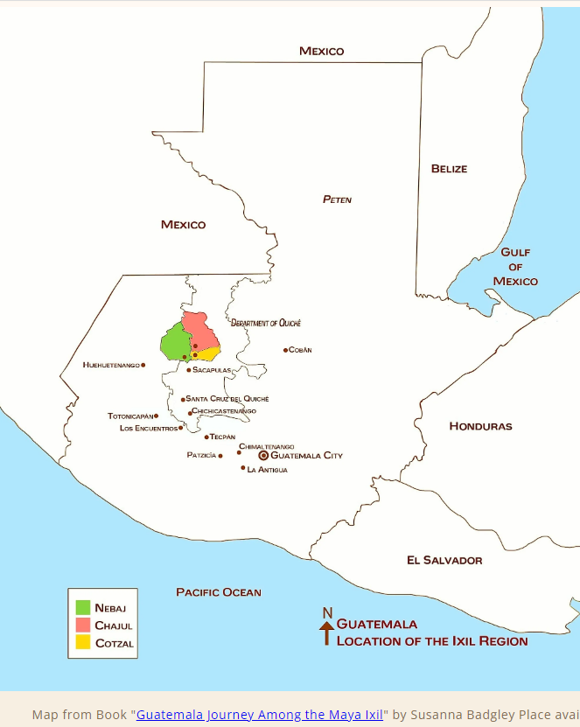

Map from Book “Guatemala Journey Among the Maya Ixil” by Susanna Badgley Place, taken from https://ixilcollective.org/pages/ixil-region

[s͡ʃ] represents a voiceless alveo-postalveolar fricative and [ts͡ʃ] a voiceless alveo-postalveolar affricate. These are sounds in which the place of articulation shifts from alveolar to post-alveolar during the production of the sound, sort of like a diphthong for vowels. The symbol [:] indicates the preceding vowel is long.

Chajul Ixil | Nebaj Ixil | Translation
[ts͡ʃem] | [t͡ʃem] | ‘bench’
[t͡ʃem] | [t͡ʃem] | ‘woven item’
[ts͡ʃoh] | [t͡ʃo:] | ‘pay’
[s͡ʃin]  [sat͡ʃil]  [ʈʂo:] | [ʃin]  [sat͡ʃil]  [ʈʂo:] | ‘compressed’  ‘squash seed’  ‘animal’
[tih] | [ti:] | ‘hard’
[pis͡ʃ]  [χoh] | [piʃ]  [χo:] | ‘divide’  ‘crow’

- Consider the postalveolar [t͡ʃ ʃ] and alveo-postalveoloar [ts͡ʃ s͡ʃ] sounds in these two dialects. What differences occur between the two dialects? (Hint: consider which sounds occur in each dialect as well as how the same words are pronounced differently in the two dialects)

[t͡ʃ] [ts͡ʃ] and [s͡ʃ] all occur in Chajul Ixil
[t͡ʃ] and [ʃ] occur in Nebaj Ixil

Words that have alveo-postalveolar sounds in Chajul have postalveolar sounds in Nebaj. Words that have postalveolar sounds in Chajul also have postalveolar sounds in Nebaj.

- Consider the glottal fricative [h] and long vowels [:] in these two dialects. What differences occur between the two dialects? (Hint: consider whether [h] and long vowels occur in both dialects and how words from one dialect correspond to the other)

Both [h] and long vowels occur in Chajul.
Only long vowels occur in Nebaj.

Words that have [h] in Chajul have long vowels in Nebaj. Words that have long vowels in Chajul also have long vowels in Nebaj.

- The following are words of Chajul Ixil. Can you guess how they would be said in Nebaj Ixil? If there is more than one option, list both, and explain why.

[s͡ʃok] ‘twisted’ [ʃok] – alveo-postalveolar sounds in Chajul correspond to plain postalveolar sounds in Nebaj

[ɓih] ‘name’ [ɓi:] – [h] in Chajul corresponds to long vowel in Nebaj

- The following are words of Nebaj Ixil. Can you guess how they would be said in Chajul Ixil? If there is more than one option, list both, and explain why.

[it͡ʃ] ‘chile’ could be [it͡ʃ] or [its͡ʃ], we don’t know because where Nebaj has a postalveolar Chajul sometimes has postalveolars and sometimes alveo-postalveolars

[ʔo:] ‘avocado’ could be [ʔo:] or [ʔoh], we don’t know because where Nebaj has a long vowel, Chajul sometimes has a long vowel and sometimes an [h]

- Based on this data, is there any way of telling which dialect of Ixil is the standard form of the language? Why or why not?

There is no way to know because which dialect is the standard has nothing to do with the linguistic forms, only with social factors.

Morphology
Nahualá K’iche’ morphemes

For each group of words, do the following:
- Identify the morpheme all the words have in common.
- Say what you think the meaning of this morpheme is. Support your answer with an example from the data.
- Say if the morpheme is a root or an affix and explain why.
- If it is an affix, say if it is a prefix or a suffix and explain why. If it is a root, leave this question blank.
- If it is an affix, say if it is derivational or inflectional and explain why. If it is a root, leave this question blank.

Group 1

waɾaɓal ‘bedroom’ (compare to waɾ ‘to sleep’)
tiχoɓal ‘school’ (compare to tiχ ‘to teach’)
atiniɓal ‘bathing place’ (compare to atin ‘to bathe’)
ɓanoɓal ‘workshop’ (compare to ɓan ‘to make’)

Morpheme: ____ɓal_____________________________________
Meaning and example: _____means ‘place’, as in waɾaɓal ‘bedroom’ = place of sleeping, from waɾ ‘sleep’ [anything reasonable is fine]_____________
Root or affix and explanation: ___affix, because it attaches to a root and does not have the core meaning of the words ______________________
If affix, prefix or suffix and explanation: __suffix, because it goes after the root/at the end of the word _____________________
If affix, derviational or inflectional and explanation: ____derivational, because it changes a verb into a noun_____________

Group 2

kasaqiɾik ‘it becomes white’ (compare to kanimaɾik ‘it becomes large’)
saqwat͡ʃ ‘potato (compare to uwat͡ʃ ‘its surface’)
saq iʃim ‘white corn’ (compare to meʃ iʃim ‘black corn’)
saqsoχ ‘off-white’ (compare to ɾaʃroχ ‘pale blue’)

Morpheme: ______saq___________________________________
Meaning and example: _____white, as in saq iʃim ‘white corn’ compared to meʃ iʃim ‘black corn’ __________________________
Root or affix and explanation: ____root, it provides the core meaning of the word and doesn’t attach to or modify something else_____________________
If affix, prefix or suffix and explanation: ____n/a___________________
If affix, derviational or inflectional and explanation: _____n/a____________

Group 3

aχɓe: ‘traveler’ (compare to ɓe: ‘road’)
aχnawalχaʔ ‘person from Nahualá’(compare to nawalχaʔ ‘Nahualá’, town in Guatemala)
aχt͡ʃa:k ‘worker’ (compare to t͡ʃa:k ‘work’)
aχke:χ ‘horseman’ (compare to ke:χ ‘horse’)

Morpheme: ____________aχ_____________________________
Meaning and example: _____agent/person, as in aχke:χ ‘horseman’ from ke:χ ‘horse’ [anything reasonable is fine]___________________
Root or affix and explanation: __affix, because it attaches to something else and isn’t the core meaning of the word _______________________
If affix, prefix or suffix and explanation: ___prefix, because it goes at the beginning/before the root ____________________
If affix, derviational or inflectional and explanation: ____derivational, because it significantly changes the meaning of the word_____________

Group 4

ʃint'iso ‘I sewed it’ (compare to ʃinɾiqo ‘I found it’)
t'isoʔn ‘sewing’ (compare to t͡ʃ'aχoʔn ‘washing’)
kat'is t͡ʃik ‘you will sew it again’(compare to kaq'at t͡ʃik ‘you will cut it again’)
t'isane:l ‘tailor’ (compare to t͡ʃ'akane:l ‘winner’)

Morpheme: _______t’is__________________________________
Meaning and example: ____sew, as in ʃint'iso ‘I sewed it’ compared to ʃinɾiqo ‘I found it’___________________________
Root or affix and explanation: _____root, because it doesn’t attach to something else, it is the core meaning of the word____________________
If affix, prefix or suffix and explanation: ____n/a___________________
If affix, derviational or inflectional and explanation: _____n/a____________

Group 5

ʔut͡salaχ ‘very good’ (compare to ʔut͡s ‘good’)
t͡ʃo:malaχ ‘very fat’ (compare to t͡ʃo:m ‘fat’)
nimalaχ ‘very bit’ (compare to nim ‘big’)
nit͡s’alaχ ‘very small’ (compare to nit͡s’ ‘small’)

Morpheme: ____________alaχ_____________________________
Meaning and example: ______very, as in nimalaχ ‘very big’ from nim ‘big’_________________________
Root or affix and explanation: _____affix, it attaches to something else____________________
If affix, prefix or suffix and explanation: ______suffix, it goes at the end/after the root_________________
If affix, derviational or inflectional and explanation: ____inflection, it doesn’t change the word class but provides a small modification in meaning_____________
Historical
Sound change in Tseltal
Tseltal is a language of the Mayan family spoken in Chiapas, Mexico. Consider the following data comparing Tseltal words to reconstructed words in Tseltal’s ancestor language, proto-Mayan. (Data modified from A preliminary Mayan etymological dictionary, 2003)
Proto-Mayan Tseltal Gloss
*saq sak ‘white’
*k’aq t͡ʃ'ak ‘flea’
*t͡s'u:nuʔn t͡s'unun ‘hummingbird’
*kita:m t͡ʃitam ‘pig’
*t͡ʃ’oʔh t͡ʃ’o ‘mouse’
*q’ahq’ k’ahk’ ‘fire’
*iʔq’ ik’ ‘wind’
*e:h e ‘tooth’
*haʔh ha ‘fly’
*u:h u ‘moon’
*k’iʔʃ t͡ʃ'iʃ ‘thorn’

- What sounds have changed from proto-Mayan to Tseltal?
Uvulars (stop and ejective) became velar
Velars (stop and ejective) became postalveolar
[h] and [ʔ] deleted
Long vowels became short

- Is each change conditioned or unconditioned? If conditioned, state the conditioning phonetic environment.
Deletion of [h] is conditioned: occurs word-finally (but not word-medially or word-initially).
The rest are unconditioned.

- Make formal rules describing each sound change. Don’t forget the conditioning environment where relevant!
*[uvular] > [velar]
*[velar] > [postalveolar]
*[h] > ∅ / _ #
*[ʔ] > ∅
*V[long] > V[short]

